Living the Byzantine Faith
A Four Week Course
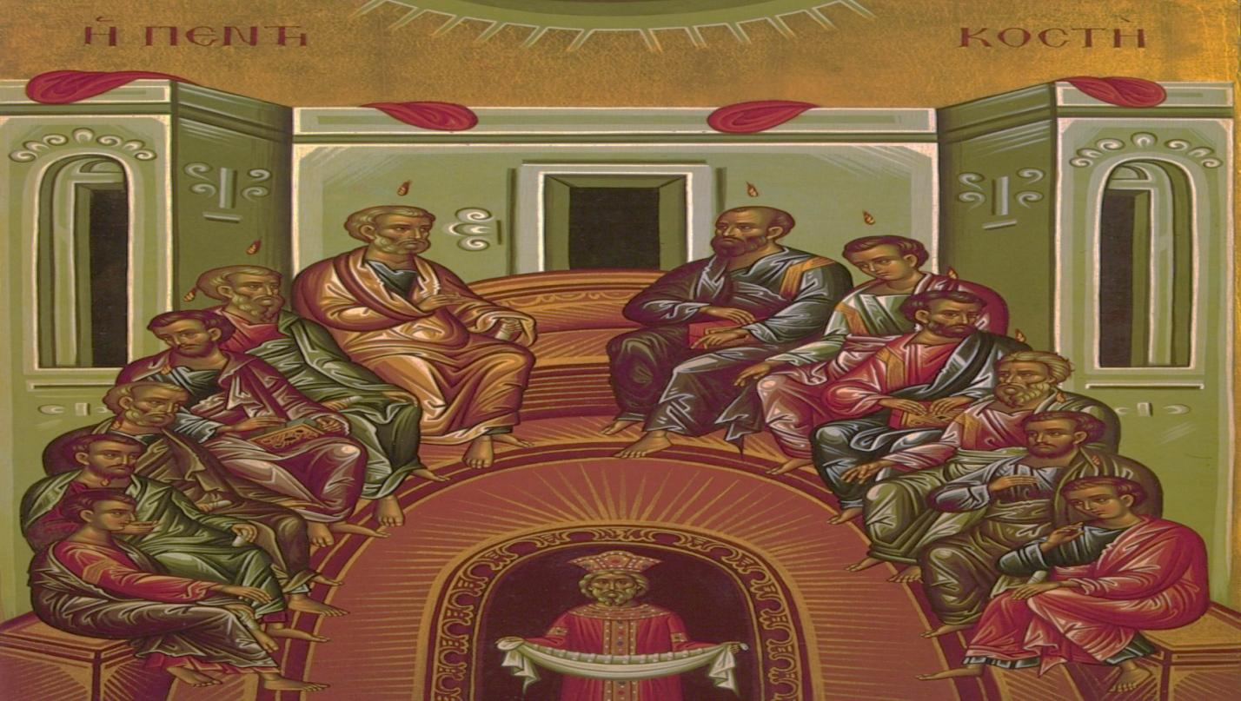
A Four Week Course Designed to Inform You and Deepen Your Faith.

ABOUT THIS COURSE
Suggestions for the Next Version
If you have any comments, suggestions, or revisions, please contact the editor at mark_koscinski@yahoo.com. The last page of this book had an evaluation form. Please turn this evaluation in at the end of the class. As ideas or comments occur to you during the four weeks, please write them down right away. Please be honest in your evaluation about the content of the course.
Icon of the Descent of the Holy Spirit
The icon on the opposing page is the Icon of the Descent of the Holy Spirit, one of the Three Persons of the Holy Trinity. The Trinity is one of the central doctrines of our Faith. We will call on the Holy Spirit for help and guidance during our course. Never hesitate to call on the Holy Spirit for help and guidance in the course of your daily life.
Attributions and Credit
We are indebted to Father Mitch Pacwa, and his book, The Year of Faith: A Bible Study Guide for Catholics, Our Sunday Visitor Publications, 2012.

Note from the Editor
This course or any of the course materials do not represent the official policy of the Eparchy of Passaic. It is purely for the purposes of informing and hopefully deepening the Faith of the participants. If it should prove to be a blessing to our Church, then thank God, as it is the Holy Spirit who works wonders in our hearts and minds. If it should prove to be troublesome, then it is no doubt the fault of this editor.

CLASS MECHANICS

- Welcome to our four-session class on Living the Byzantine Faith!
- Each class will last forty-five minutes and will start promptly at the scheduled time.
- Please take a workbook. We only have made enough copies for everyone in the class. Please do not take an extra one.
- Try to do the homework before each class. It will help your understanding, and it will make the class run much smoother.
- Each class will be independent of all the others. If you miss one, no problem!
- Please feel free to take notes but the PowerPoint slides can be emailed at the end of the class upon request.
- We invite questions during the class, but please understand that our time is limited. The four classes are jammed with information. Consequently, we can deal with some simple questions during the course. Please do not feel upset if we don’t deal with your question right away, but we will try to cover all of the promised material. I will be available after class to continue the discussion, or can continue the discussion via email.
- Try to bring your Bible to the Class. We will refer to it often.
- It does not matter which version of the Bible that you use, but sometimes the translation will be different. For our purposes, one is not better than another.
Getting to be friends with your Bible in the Year of Faith is a good thing!
What Bible Should I Use?
Any translation of the Bible which is generally accepted by the Catholic or Orthodox Churches will be fine for this course. There will be differences in translation, but they will not be material for this course. If you are looking to purchase a Bible, the St. Joseph Bible (Catholic), the Orthodox Study Bible (Orthodox) or the New Revised Standard Bible are excellent translations and an outstanding prayer resource. Pay particular attention to the quality of the footnotes and other useful items such as maps of the biblical era. They will help your understanding of the course.

Course Outline
Faith in the Trinity
Week one

Faith in Jesus
Week Two

Faith and Conversion
Week Three

Faith and Daily Life
Week Four

This course will use the tools given to us by the Eastern Christian Church to enhance our understanding of the Faith. Extensive use of icons, our common prayers, and the Church Fathers will be employed for the four weeks. We will follow the Tradition and Magisterium of the Universal Catholic Church.

What is an Icon?
(Source:http://www.orthodoxa.org/GB/orthodoxy/iconography/whatisaniconGB.htm)
The word "icon" means "image," but since the early centuries of Christianity, the word "icon" is normally used to refer to images with a religious content, meaning and use. Most icons are two-dimensional; mosaics, paintings, enamels, miniatures, but ancient three dimensional icons also exist. Many people assume an icon must be in a Byzantine or Russian style. Many icons are, but many are not; other Orthodox Christian cultures have their own traditional styles of art, and many icons exist painted in a Western style. It is not style that makes a painting an icon; it is subject, meaning and use. An icon is always the representation of a religious subject, but not every representation of a religious subject is an icon. An icon is not simply the representation of a religious subject; it is a representation with a religious meaning.

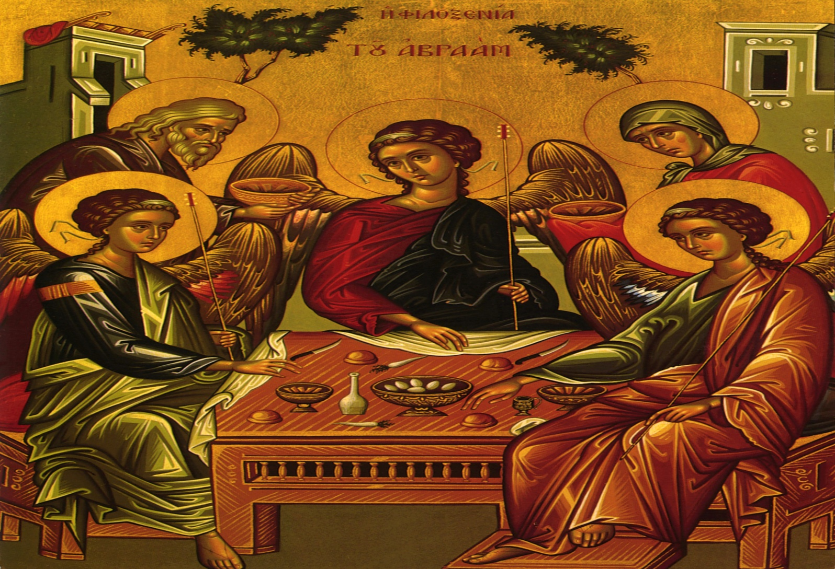
“The Father looks forward, raising his hand in blessing to the Son. It is impossible to tell whether he looks up at the Son or down to the chalice on the table, but his gesture expresses a movement towards the Son. This is My Son, listen to Him… The hand of the Son points on, around the circle, to the Spirit. In this simple array we see the movement of life towards us, The Father sends the Son, the Son sends the Spirit. The life flows clockwise around the circle. And we complete the circle. As the Father sends the Son, as the Son sends the Holy Spirit, so we are invited and sent to complete the circle of the Godhead with our response. And we respond to the movement of the Spirit who points us to Jesus. And he shows us the Father in whom all things come to fruition. This is the counter-clockwise movement of our lives, in response to the movement of God. And along the way are the three signs at the top of the picture, the hill, the tree, and the house.“
(source: http://www.sacredheartpullman.org/Icon%20explanation.htm)

The Spirit touches us, even though we do not know who it is that is touching us. He leads us by ways we may not be aware of, up the hill of prayer. It may be steep and rocky, but the journeying God goes before us along the path. It leads to Jesus, the Son of God, and it leads to a tree.



Introductory Prayer
In the name of the Father,  and of the Son and of the Holy Spirit. Amen.
Glory to You our God, Glory to You.
Prayer to Holy Spirit
Heavenly King, Comforter, the Spirit of Truth, present in all places and filling all things, Treasury of Blessing and Giver of life: come and dwell within us. Cleanse us of all stain, and save our souls, O Gracious Lord.
Trisagion Prayer
Holy God,  Holy and Mighty, Holy and Immortal, have mercy on us. (3)
Glory to the Father,  and to the Son and to the Holy Spirit, now and ever and forever. Amen.
Most Holy Trinity, have mercy on us. Lord, cleanse us of our sins. Master, forgive our transgressions. Holy One, come to us and heal our infirmities, for Your name’s sake.
Lord, have mercy. (3)
Glory to the Father,  and to the Son and to the Holy Spirit, now and ever and forever, Amen.
Lord’s Prayer
Our Father, Who art in Heaven, hallowed be Thy name. Thy Kingdom come, Thy will be done, on earth as it is in Heaven. Give us this day our daily bread; and forgive us our trespasses, as we forgive those who trespass against us; and lead us not into temptation, but deliver us from evil. For Thine is the Kingdom and the Power and the Glory, Father,  Son and Holy Spirit, now and ever and forever. Amen.
These prayers were given to St. Pachomius by an Angel. We use these prayers to begin almost any prayer service we attend. They are recited by the priest and deacon before the beginning of the Divine Liturgy as they prepare for the service. These prayers are Trinitarian in nature, invoking the Father, Son, and the Holy Spirit. As you go through this course, you will see how fiercely Trinitarian Byzantine worship is.

SUGGESTED READINGS FOR CLASS 1
These Readings from the Bible will be covered in class:
- Baptism in the Jordan (Mt. 3:16-17, Lk. 3:21-22)
- The Great Commission (Mt. 28:19)
Supplemental Bible Readings:
- Matthew 23:1-35—Jesus discusses the Pharisees
- Romans 16: 25-26—Mystery
Writings of the Church Fathers:
St. Basil the Great, “De Spiritu Sancto”. http://www.episcopalnet.org/READINGS/Basil/Bhs/index.html
It is no good asking for a simple religion. After all, real things are not simple. They look simple, but they are not. The table I am sitting at looks simple: but ask a scientist to tell you what it is really made of—all about atoms and how the light waves rebound from them and hit my eye and what they do to the optic nerve and what it does to my brain—and, of course, you find that what we call "seeing a table" lands in mysteries and complications which you can hardly get to the end of.
C.S. Lewis, “Mere Christianity”

THE TRINITY
The Trinity is a Central of our Faith. There have been many attempts to explain or simplify the Trinity. Several examples of this follow:
The Classic formulation:
- The Father is God
- The Son is God
- The Holy Spirit is God
- The Father is not the Son.
- The Son is not the Holy Spirit
- The Holy Spirit is not the Father
- There is One God!

St. Patrick:

The Trinity is like a clover leaf. There is one clover, but with three leaves.

Eastern formulation:

The Monarchy of the Father. The Son proceeds from the Father, and the Holy Spirit processes from the Father. The Father is the source of the Godhead.

Augustinian formulation:

The Holy Spirit is the love between the Father and the Son.

The Mathematical formulation:

While 1+1+1=3, consider that:

1 x 1 x 1 = 1.

The exponent comes out the same:

1³ = 1

And:

Infinity + infinity + infinity = infinity.

There are many, many more. Explaining the infinite though often results in a failure of words, which are finite. That is one of the reasons why there is often such disagreement in the nature of the Trinity over time and the subsequent need for Ecumenical Councils to resolve the controversies. Yet, despite two millennia of discussion, the nature of the Trinity still remains an essential mystery of our Faith?

Which explanation of the Trinity do you favor? Which do you not like? Why?

______________________________________________________________________________________________________________________________________________________________________________________________________________________________________________________________________________________________________________________________________________________________________________________________________
As a result of these discussions of the nature of the Trinity and the Christological controversies we will discuss next week, the Fathers of the First and Second Ecumenical Council formulated the Creed, also called the Symbol of the Faith.

Why do you think it is called a Symbol?
______________________________________________________________________________________________________________________________________________________________________________________________________________________________________________________________________________________________________________________________________________________________________________________________________

I BELIEVE….
What is the Creed?
It is our basic beliefs as Christians. In our Church, we do not recite it, we PRAY it!
Why do we need the Creed?
Jesus was very sharp when he rejected certain practices of the Pharisees. He said they did not observe the Spirit, but the letter of the Law. Jesus did not take lightly to those who contradicted his Gospel. It is particularly important to understand the Jewish belief systems at the time. The Law was just not the Ten Commandments. The first five books of the Bible (“the Torah”) contained 613 commandments. Even today, a pious Jew will “put a fence around the Law.” This fence is the oral tradition that set other restrictions so you could not possibly break the Law. One example of this is the rules concerning the Sabbath. You could only walk so far on the Sabbath for recreation. If you walked too far, it was then work. Another example was the dietary laws. Jesus rejected the RITUAL aspects of the Jewish Law, but kept the MORAL aspects of the Law.
Some early Christians began to change the teachings of the Gospel. They were opposed by other early Christians, who understood the very Faith was being attacked by these changes. They strongly responded. As Christian doctrine developed, arguments began to arise about the Trinity and the person of Jesus (“Christological” questions.)
These incorrect views started very early in the Church. There are many examples of incorrect beliefs throughout the New Testament. There are a few listed below. Make some notes for discussion in class.

PASSAGE | COMMENTS
1 John 2:18-25; 4:1-6
2 Peter 2:1-3:4
Philippians 3:2-11, 17-21

There are many more examples in the Scriptures? Can you find others?

________________________________________________________________________________________________________________________________________________________________________________________________________________________________________________________________________________________________________________________________________________________________________________________________________________________________________________________________________

Over time, the followers of the True Faith became known as the “Orthodox Catholics”. Those who did not became known as the “heterodox” or the “heretics”. Throughout the history of the Church, there have been many flavors of heresy. One of the most famous was Arianism, which stated that Jesus was a creature, created by the Father. There were many others. Can you name a few?

_________________________________________________________________________________________________________________________________________________________________________________________________________________________________________________________________________________________________________________________________________________________________________________________________________________________________________

It is important to remember that our Faith is often like a “tug of war”. When one side pulls too hard, he Faith “goes out of kilter”, and a heresy results. The Church Councils were often called to restore balance into the Church after these famous heresies. In many ways, the statements of our Faith resulted from statements in opposition to heresy.

THE FIRST SEVEN ECUMENICAL COUNCILS
Nicaea (325)—Opposed Arianism and wrote the Nicene Creed.
I Constantinople (381) —Added the doctrine of the Holy Spirit to the Nicene Creed. Our Creed is now known as the Nicene-Constantinopolitan Creed.
Ephesus (431) —Opposed Nestorianism and proclaimed Mary “Theotokos,” the God-Bearer.
Chalcedon (451) —Opposed Monophysitism and proclaimed the “hypostatic union” of the two natures of Jesus.
II Constantinople (553) —Further opposed Nestorianism.
III Constantinople (680) —Opposed Monothelitism, which said Jesus did not have a human will.
II Nicaea (787) —Opposed Iconoclasm and upheld the veneration of icons.
These first Seven Ecumenical Councils are honored by both the Catholic and Orthodox faiths. Many Protestant denominations do not use a Creed, but implicitly abide by it.

Commemorations of the Ecumenical Councils

First Ecumenical Council—Seventh Sunday After Easter
First Six Ecumenical Councils—Ninth Sunday After Pentecost
Seventh Ecumenical Council—The Sunday following October 11

WHAT IS THE “FILIOQUE?”

OUR CREED
I believe in one God, the Father Almighty, Creator of heaven and earth, of all things visible and invisible;
And in one Lord, Jesus Christ, Son of God, the only begotten, born of the Father before all ages. Light from Light, true God from true God, begotten, not made, one in essence with the Father; through whom all things were made. For us and for our salvation, He came down from heaven, and was incarnate from the Holy Spirit and the Virgin Mary, and became man. He was crucified for us under Pontius Pilate; and suffered and was buried. He rose on the third day according to the Scriptures. He ascended into heaven, and is seated at the right hand of the Father; and He is coming again in glory to judge the living and the dead, and his kingdom will have no end.
And in the Holy Spirit, the Lord, and Creator of Life, who proceeds from the Father; together with the Father and the Son He is worshiped and glorified; He spoke through the prophets; In one, holy, catholic and apostolic Church.
I profess one baptism for the remission of sins; I expect the resurrection of the dead, and the life of the world to come. AMEN.

Over the centuries, the Western Church had to deal with outbreaks of Arianism. In an attempt to strengthen the Creed against the Arians, some dioceses began to add the phrase “…and the Son” to describe the Procession of the Holy Spirit. Eventually, it became the formula used throughout the Western Church. Eastern Churches, such as us, have kept the original Creed, which states the Holy Spirits proceeds only from the Father.
The Eastern Church thought it was extremely important to precisely state the belief in One God in Three Persons, particularly since it was often under pressure from Muslim and Jewish groups. They often claimed Christians were really Polytheists, believing in many Gods, and not Monotheists. The Eastern Church taught the “Monarchy of the Father”, which stated that the Father begets the Son, and the Spirit proceeds from the Father.
The Filioque was once the source of a great deal of discussion and disagreement between the Eastern and Western Churches. Recently, this contentiousness has died down, as some formulations have been suggested to reconcile the view. What did not divide the Church in the early ages of Christianity should not be a source of scandal now.
We also need to remember that sometimes various Christian groups use slightly different version of the Creed. Most of the time this is due to the use of different translations. This too, should not be a source of division between Christians.
Note the Centrality to Baptism to the Christian Faith. It is our entrance into the life of faith.

THE CHURCH FATHERS

The Church Fathers were the saintly writers and expounders of the doctrines of the Faith. They are often spoken of in various groups or classifications. Here are a few such grouping:

The Great Doctors of the Church
The Greek Doctors The Latin Doctors
St. Athanasius St. Jerome
St. Basil the Great St. Gregory the Great
St. Gregory the Theologian St. Ambrose
St. John Chrysostom St. Augustine

The Cappadocian Fathers
St. Basil the Great
St. Gregory of Nyssa
St. Gregory the Theologian

The Three Holy Hierarchs
St. Basil the Great
St. Gregory the Theologian
St. John Chrysostom

Description of the Church Fathers Grouped by Era
The Apostolic Fathers
The Pre-Nicene Fathers
The Post-Nicene Fathers

The Apostolic Fathers were those that wrote shortly after the New Testament Era. It is through these Fathers that Tradition was passed to us from the Apostles. Examples are:
Clement, Bishop/Presbyter of Rome (late first century: d. ca. 100).
In his Letter to Corinth, ‘1 Clement’ (ca. 95), he deals with the issue of establishing an orderly (apostolic) succession of leaders among the elders and speaks against Judaizing and Docetic influences in Corinth (Docetism is a doctrine which states that Christ’s body was not human, but either an illusion, or of real but celestial substance, and that therefore His sufferings were only apparent).
Ignatius, Bishop of Antioch (ca. early 100s)
Ignatius wrote a number of letters while on the way to Rome to be executed. In these, he urges the churches to build a ministerial pattern of one bishop and several presbyters and deacons. The bishop was to have the key responsibility of maintaining the unity of the church and its doctrines against the diverse interests pulling at the churches.
Polycarp (martyred. ca. 160)
Polycarp was reputed to be a direct disciple of the apostle John. He eventually became Bishop of Smyrna. The story of his martyrdom as an old man was widely circulated throughout the early church as a testimony of faith. He knew St. John the Theologian in his old age. He was celebrated on the First Sunday of the Great Fast before the iconography controversy.

The Pre-Nicene Fathers wrote before the First Ecumenical Council. Examples are:
Justin "Martyr" (d. 165)
Justin underwent his own philosophical/spiritual journey as a young man. Along the way he studied Stoicism, Aristotelianism, Pythagorism, Platonism. He finally became a convert to Christianity on the basis of the integrity and bravery of its martyrs. He became a teacher in Rome--and died a martyr there rather than sacrifice to the gods.
He took up the task of relating Christianity to Greek philosophy--especially Platonism (which he still respected). He stressed (along with the gospel-writer John) that Christ was the Logos. He claimed also that Plato had been inspired by the Old Testament. And finally he put forth the idea that Christianity was the completion of what earlier Greek philosophers were trying to arrive at.
Irenæus, Bishop of Lyons (ca. 130-202)
Irenæus was born into a Greek Christian family of Asia Minor. He became a disciple of Polycarp--but was also influenced by Justin’s philosophy. He moved to Lyons (Gaul or France) as a young man, becoming a presbyter there--in 177 succeeding the martyred bishop and living on at Lyons until his death possibly at the beginning of the 200s.
He took up the theological task of refuting the Gnostic heresy. His writings give us much of our knowledge (negatively biased, of course) of the Gnostics. The Gnostic claim of possessing special secret knowledge not given to other Christians he refuted with the claim that the apostles would have passed such knowledge on to the churches they themselves founded and loved--if such knowledge had actually existed.
Also--he noted that the apostolic churches all proclaimed the same set of doctrines out of a well-recognized set of apostolic writings (the New Testament)--outweighing, by way of true authority, the ridiculous and contradictory innovations of the Gnostics and their writings.
Clement of Alexandria (Titus Flavius Clemens) (ca. 150-215)
He was born a Greek pagan, but converted to Christianity and studied under a number of Christian teachers--principally Pantænus, head of the Christian school in Alexandria (whom he succeeded in around 190).
Egypt at the time was falling heavily under the influence of Gnosticism. Clement took up the cause of defending orthodox Christianity through demonstrating its conformity to well accepted Greek philosophy--proving orthodox Christianity to be thus a higher version of Christianity (and also the consummation of Greek philosophy). Clement’s answer to Gnosticism was to demonstrate true Christian "gnosis": the discipline of ethical living and the disciplined contemplation of God.
Tertullian (ca. 160-225)
Tertullian was a Latin Carthaginian who was born a pagan and trained in rhetoric and the law. He converted to Christianity just before the turn of the century. He seems to have remained all his life a teacher--probably never becoming a bishop or even presbyter. But he was an excellent writer in Latin--and very influential in formulating Latin theology.
He was a very strong opponent of Sabellius--laying out one of the earliest Orthodox statements on the nature of the Trinity.
Cyprian, Bishop of Carthage (martyred in 258)
Cyprian was born of an upper-class pagan family and destined for a life in high public office--until he converted to Christianity around 245 because of the high moral qualities of the faith.
Only a few short years later he was made bishop of Carthage! He then had to lead the Carthaginian church during the Decian persecutions of 249-251--which was aimed first at the death of all Christian bishops. Cyprian, warned in advance, was able to hide--though this gave jealous clergy, who had resented his rapid rise, a chance to criticize him.
Then the persecution was directed against all Christians, forcing them, under penalty of death, to sacrifice to the pagan gods--including importantly the emperor-god. A large numbers of Christians apostatized (gave up their Christian faith) under this unexpected pressure.
Then when just as suddenly the persecutions ended--the problem emerged of readmitting apostatized Christians back into the fold: who should have the power to readmit them and under what terms? The Church fell into deep internal dissent over the matter.
Some of the more rigorous Christians withdrew in anger at the ease by which Christians were being forgiven for their apostasy--and withdrew to set up separate churches. The unity of the church was threatened.
Cyprian pressed for forgiveness and unity--and claimed that only the bishops, not the most rigorous individuals (“confessors”), had the right to restore the apostates.
His views influenced greatly the idea of a church ruled by ordained bishops and not by charismatic individuals.

Anthony of Egypt (251-356)
Anthony was a religious hermit in the Egyptian desert (along the lower Nile) who was considered the first organizer and inspirer of monastic Christian life. As a young man of about 20 he took up the practice of asceticism (self-denial). At about the age of 35 he took to the desert to live in total isolation--remaining in that condition for nearly 20 years. During these years he was engaged in an on-going struggle with visions of Satan--and in the perfecting of his spiritual life.
The stories of his struggles began to inspire the larger Christian world (including Athanasius who was to write a biography: Life of Anthony). Indeed, over the years a large number of other Christian ascetics had gathered around him to imitate his discipline, and in 305 Anthony ended his isolation in order to instruct others in the monastic life. Eventually he organized a monastery, Dayr Mari Antonios, on a mountain near the Nile--which stands to this day.
The Post-Nicene Fathers included the Great Doctors of the Faith and Gregory of Nyssa. We are most familiar with their works.

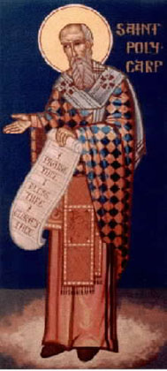
How Was The Christian Faith Transmitted?
One such example is through St. Polycarp, whose icon appears to the left. Polycarp was extremely long lived, as was St. John the Theologian. St. Irenæus reports that as a young man, he heard St. Polycarp preach, and say that he (Polycarp) had known St. John. He was the only Apostle not to be martyred. St. Irenæus died in 202 AD. Eusebius wrote the Church History in the Fourth Century, using sources long since lost. One can point to a solid chain of evidentiary history back to the Apostles.
St. Polycarp

SOME NOTABLE HERESIES
Why are we interested in heresies?

The answer is there is really nothing new under the sun. There are certain themes that continue to resurface century after century. For instance, many of the “New Age” doctrines are simply centuries old ideas that have surfaced under another name. The writings of the Church Fathers are as equally relevant today as they were then. So, let’s take a look at some of these ideas….

ADOPTIONISTS. Jesus was not the Son of God from all time. He only became the Messiah when he was baptized in the Jordan.

ARIANS. Followers of the priest Arius, who believed that Jesus was not God (the “Uncreated”), but rather a creature who was part of God’s creation (the “Created”). Their rallying cry was “there was a time when He was not.”

DOCETISTS. Jesus did not die on the Cross. His body was an illusion or there was a substitute.

EBIONITES. A group of extreme Judaizers in the early church. Their influence was sharply curtailed in after the Roman destruction of Jerusalem in the First Century AD. They advocated a stricter adherence to the Jewish law.

GNOSTICS. They came in many forms, but generally, they were believers in secret, esoteric knowledge that would divide the Christians into two camps: the Enlightened and those not Enlightened. Christianity has always strived to say it was one. As St. Paul says, there is “neither Greek nor Jew….”. Many of the “New Age” movements are simply a restatement of Gnostic beliefs.

ICONOCLASTS. Destroyer of icons. A later heresy.

MODALISTS. There is no Trinity. God simply reveals himself in three “Modes”, or under three different aspects.

MONOPHYSITES. Jesus did not have two natures. He had one—that of God. Recently, there has been much discussion about reconciling this view to the Catholic view of the Two Natures of Jesus.

MONOTHELITISTS. Jesus had two natures, but only one will. This was a compromise theology in an attempt to reconcile various factions such as the Monophysites.

NESTORIANS. Jesus is not the Son. He is united with the Son. Hence, Jesus does not have two natures, but has two persons. Jesus was in essence, two persons, human and divine, loosely connected.

NON-CHALCEDONIANS. A collective term generally denoting Christians who did not believe the Church’s belief in the two natures of Jesus.

PELAGIANS. We can gain salvation under our own initiative. We do not necessarily need God’s grace. It is all within us to do. They were vigorously opposed by St. Augustine.

SABELLIANSIM. Another form of Modalism.

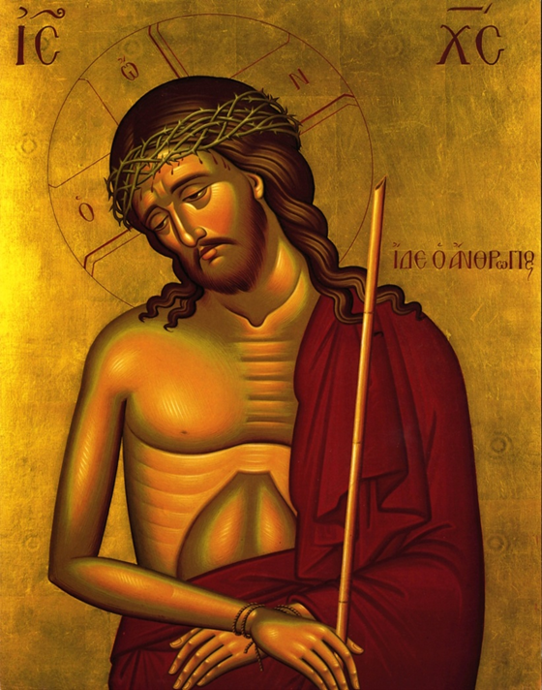
Living the Byzantine Faith

Class 2—Faith in Jesus

OPENING PRAYER
In the name of the Father,  and of the Son, and of the Holy Spirit. Amen.
Glory to You our God, Glory to You.
Prayer to Holy Spirit
Heavenly King, Comforter, the Spirit of Truth, present in all places and filling all things, Treasury of Blessing and Giver of life: come and dwell within us. Cleanse us of all stain, and save our souls, O Gracious Lord.
Trisagion Prayer
Holy God,  Holy and Mighty, Holy and Immortal, have mercy on us. (3)
Glory to the Father,  and to the Son and to the Holy Spirit, now and ever and forever. Amen.
Most Holy Trinity, have mercy on us. Lord, cleanse us of our sins. Master, forgive our transgressions. Holy One, come to us and heal our infirmities, for Your name’s sake.
Lord, have mercy. (3)
Glory to the Father,  and to the Son and to the Holy Spirit, now and ever and forever, Amen.
Lord’s Prayer
Our Father, Who art in Heaven, hallowed be Thy name. Thy Kingdom come, Thy will be done, on earth as it is in Heaven. Give us this day our daily bread; and forgive us our trespasses, as we forgive those who trespass against us; and lead us not into temptation, but deliver us from evil. For Thine is the Kingdom and the Power and the Glory, Father,  Son and Holy Spirit, now and ever and forever. Amen.

Readings for Class
Bible Readings to be covered in Class:
- Mt. 23: 1-35—Jesus and the Pharisees
- Jn. 20:15-16—Jesus after the Resurrection
Supplementary Readings:
- The Gospel of Matthew—Fulfillment of the Prophecies of the Old Testament
- The Gospel of Mark—Miracles of Jesus
- Excerpt of the writings of the Church Fathers concerning Jesus

Who is Jesus?
Many recent books and novels had made the claims that the divinity of Jesus was only a comparatively late invention. The evidence of the Gospels and of the early Church Fathers is much different. They present an overwhelming amount of evidence to support the proposition that Jesus is in fact the Son of God. The Gospel of St. Matthew was written for the Jewish people. One of its aims was to show how Jesus fulfilled the prophecy of the Old Testament. Scan the Gospel, and note how many times the phrase “This was to fulfill…” is used. Write down a few below for class discussion.

______________________________________________________________________________________________________________________________________________________________________________________________________________________________________________________________________________________________________________________________________________________________________________________________________

Jesus also worked many signs that demonstrated his divinity. Scan the Gospel of Mark, and look for some of his miracles. Write down some of the miracles contained in the Gospel for class discussion.

__________________________________________________________________________________________________________________________________________________________________________________________________________________________________________

Jesus was different than those who came before him, including Moses and Buddha. He affirms the moral law that was announced in the Old Testament. As such, He was indeed a great moral teacher. We are bound to obey those moral laws. However, he is much more. He makes claims about His own person. Jesus is an object of human faith. We as Christians are bound to believe His claims. He is not just a miracle worker or a prophet. We make an act of faith to have a personal relationship with Jesus.

Who do you say Jesus is?

______________________________________________________________________________________________________________________________________________________________________________________________________________________________________________________________________________________________________________________________________________________________
It was precisely his death that prevented the Jews from accepting Jesus as the Messiah. Leviticus curses the man hung on a tree. As one Biblical Scholar put it, for the Jews to accept Jesus as the Messiah would be like us accepting David Koresh as the Messiah. Koresh was also killed also by the authorities. Luckily for us, he was not the Messiah.
We embrace the Crucifixion and Resurrection of Jesus. It was not an embarrassment to the earliest Christians. The Letters of St. Paul are filled with many such references:
“We preach Christ crucified, a stumbling block to Jews and folly to the Gentiles.” (1 Cor. 2:23): and “…Be it for me to glory except in the Cross…” (Gal. 6:14). There are many more.
We remember the Cross on Wednesdays and Friday, and in a Special way, on Good Friday. Other major feast days associated with the Cross are August 1 (the Procession of the Cross) and September 14 (the Exaltation of the Cross). Just as a side note, the Exaltation of the Cross continues on the Roman Calendar as a solemnity, so the vestment color is red if that day falls on a Sunday. It is one of the very few days on the Byzantine calendar where dark vestments are worn on Sunday. The Cross is also commemorated on the Third Sunday in Lent, as a reminder of where our Lenten journey leads to.
St. Paul says without the Resurrection Christianity is reduced to an absurdity. It is not only his Death, but also his Resurrection that reconciles us to God. The Byzantine Church always keeps the Resurrection in mind when discussing the Resurrection, and vice versa. It is the Resurrection that gives meaning to the Crucifixion, and vice versa.
Even the early Christians had problems believing. We must always remember that Christianity is rooted in history.

Why Did Jesus Die and Rise?
Some words of St. Athanasius to give you one perspective on why Christ had to die:
1. For this purpose, then, the incorporeal and incorruptible and immaterial Word of God comes to our realm, nevertheless He was not far from us before. For no part of Creation is left void of Him: He has filled all things everywhere, remaining present with His own Father. But He comes in condescension to show loving-kindness upon us, and to visit us. 2. And seeing the race of rational creatures in the way to perish, and death reigning over them by corruption; seeing, too, that the threat against transgression gave a firm hold to the corruption which was upon us, and that it was monstrous that before the law was fulfilled it should fall through: seeing, once more, the unseemliness of what was come to pass: that the things whereof He Himself was Artificer were passing away: seeing, further, the exceeding wickedness of men, and how by little and little they had increased it to an intolerable pitch against themselves: and seeing, lastly, how all men were under penalty of death: He took pity on our race, and had mercy on our infirmity, and condescended to our corruption, and, unable to bear that death should have the mastery–lest the creature should perish, and His Father’s handiwork in men be spent for naught–He takes unto Himself a body, and that of no different sort from ours. 3. For He did not simply will to become embodied, or will merely to appear. For if He willed merely to appear, He was able to effect His divine appearance by some other and higher means as well. But He takes a body of our kind, and not merely so, but from a spotless and stainless virgin, knowing not a man, a body clean and in very truth pure from intercourse of men. For being Himself mighty, and Artificer of everything, He prepares the body in the Virgin as a temple unto Himself, and makes it His very own as an instrument, in it manifested, and in it dwelling. 4. And thus taking from our bodies one of like nature, because all were under penalty of the corruption of death, He gave it over to death in the stead of all, and offered it to the Father-doing this, moreover, of His loving-kindness, to the end that, firstly, all being held to have died in Him, the law involving the ruin of men might be undone (inasmuch as its power was fully spent in the Lord’s body, and had no longer holding-ground against men, his peers), and that, secondly, whereas men had turned toward corruption, He might turn them again toward incorruption, and quicken them from death by the appropriation of His body and by the grace of the Resurrection, banishing death from them like straw from the fire.
From On the Incarnation of the Word of God, by St. Athanasius the Great of Alexandria
Christ, the incarnate Word of God and true God of true God, died in order to destroy death and to grant us life by His glorious Resurrection. Forgiveness alone may remit the penalty for our sin, if you think of sin as offense committed against a holy, wrathful God, but it cannot give us life. Only through the destruction of death by Christ’s death and resurrection can we receive life.

THE EARLY FATHERS ON JESUS

Source: https://www.crossroadsinitiative.com/library_article/64/Divinity_of_Christ_Invented_by_Constantine___Evidence_from_the_Early_Church_Fathers_on_the_Divinity_of_Christ.html

Selected Ante-Nicene Patristic witnesses to Christ’s Divinity
A. Ignatius of Antioch, on the Divinity of Christ, calls Jesus God 16x in 7 letters (ca. 110 AD)
1. “Jesus Christ our God” Eph inscr, Eph 15:3, Eph 18:2, Tral 7, Ro inscr 2x, Ro 3:3, Smyr 10:1.
2. He speaks of Christ’s blood as “God’s blood” Eph 1:1
3. He calls Jesus “God incarnate” Eph 7:2
4. In Jesus “God was revealing himself as a man” Eph. 19:3.

B. Epistle to Diognetus (ca. 125 AD) speaking of God the Father, he says:
1. Diognetus 7:2 "he sent the Designer and Maker of the universe himself, by whom he created the heavens and confined the sea within its own bounds" (ca. 125 AD)
2. Diognetus 7:4 “He sent him as God; he sent him as man to men."

C. Melito of Sardis on Christ’s Divnity (d. ca. 190) On the Pasch (Peri Pascha).
1. Translation in Lucien Deiss, ed., Springtime of the Liturgy (Collegeville, MN: Liturgical Press, 1979), 97-110.
2. Peri Pascha was only discovered in 1940 and published in 1960.
3. he says Christ "rises from the dead as God, being by nature both God and man" (p. 100 in Deiss, physei Theos n kai anthropos).
4. he also has an anti-Gnostic insistence on Christ’s true humanity.

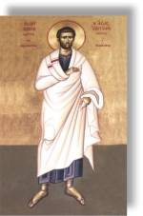
D. Justin Martyr on the Divinity of Christ (c. 155 AD)
1. says that Christians adore and worship the Son as well as the Father. 1st Apology 6.
2. says Christ, the Word incarnate, is divine 1 Apol 10 & 63

E. Irenæus on Christ’s Divinity (ca. 185) in his work Adversus Hæreses (Against Heresies)
1. Of Jesus he says "He is the holy Lord, the Wonderful, the Counselor, the Beautiful in appearance, and the Mighty God, coming on the clouds as the Judge of all men; --all these things did the Scriptures prophesy of Him." AH III.19.2 (Ante Nicene Fathers 1: 449).
2. "He, therefore who was known, was not a different being from Him who declared, ‘No man knoweth the Father,’ but one and the same, the Father making all things subject to Him; while He received testimony from all that He was very [true] man, and that He was very [true] God, from the Father, from the Spirit, from angels, from the creation itself, from men, from apostate spirits and demons, from the enemy, and last of all, from death itself." AH, IV, 6,7 (ANF, 469).

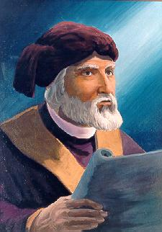
F. Tertullian on the Divinity of Christ (ca. 200)
1. The first use of the Latin word trinitas with reference to God is in Adversus Praxean and De pudicitia. The first to use the term persona in a Trinitarian & christological context asserting in Adv. Praxean 12 that the Logos is distinct from the Father as person and that the Holy Spirit is the "third person" in the Trinity."
2. Adv. Praxean 27 states that there are two natures, one human and one divine, which are joined in the one person Jesus Christ.
3. In his Apology 21, speaking of the Word, he says, “we have been taught that he proceeds forth from God, and in that procession He is generated; so that He is the Son of God, and is called God from unity of substance with God. …Thus Christ is Spirit of Spirit, and God of God, as light of light is kindled. …That which has come forth out of God is at once God and the Son of God, and the two are one. In this way also, as He is Spirit of Spirit and God of God, He is make a second in manner of existence--in position, not in nature… in His birth God and man united.”
4. In On the Flesh of Christ 5, he asks, “Was not God really crucified?”

G. Clement of Alexandria on Christ’s Divinity (ca. 210 AD)
1. Exhortation to the Heathen, 1: “This Word, then, the Christ, the cause of both our being at first (for He was in God) ad of our well-being, this very Word has now appeared as man, He alone being both, both God and man--that Author of all blessings to us. …This is the New Song, the manifestation of the Word that was in the beginning, and before the beginning.”

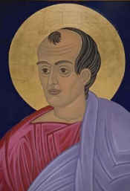
II. A few selected Trinitarian Texts from Ante-Nicene Fathers
A. Didache (ca. 125 AD) "then baptize in running water in the name of the Father and of the Son and of the Holy Spirit. (Early Christian Fathers, p. 7)
B. Ignatius of Antioch (ca. 115 AD) exhorts the Christians at Magnesia to stand firm "in faith and love, in Son, Father, and Spirit." (Mag 13)
C. Pope Dionysius to Dionysius of Alexandria, 262 AD. Uses the term Trinity and describes the unity of the three persons to prove that they are not three gods. Neunier-Dupuis, The Christian Faith, #301-303.
D. Origen (ca. 230 AD), On First Principles 1.6.2 “For in the Trinity alone, which is the author of all things, does goodness exist in virtue of essential being; while others possess it as an accidental and perishable quality, and only then enjoy blessedness, when they participate in holiness and wisdom, and in divinity itself.”

The Year of Faith: A Byzantine Perspective
Living the Byzantine Faith

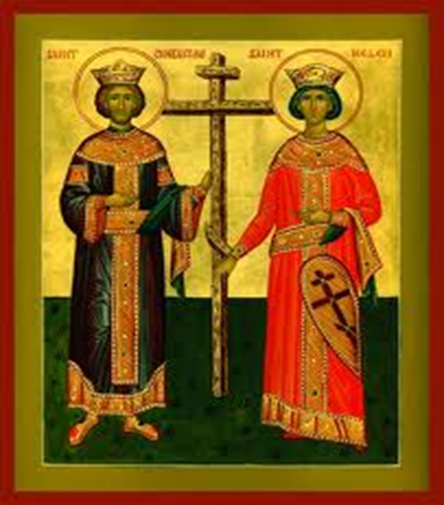

Class 3—Faith and Conversion

OPENING PRAYER
In the name of the Father,  and of the Son and of the Holy Spirit. Amen.
Glory to You our God, Glory to You.
Prayer to Holy Spirit
Heavenly King, Comforter, the Spirit of Truth, present in all places and filling all things, Treasury of Blessing and Giver of life: come and dwell within us. Cleanse us of all stain, and save our souls, O Gracious Lord.
Trisagion Prayer
Holy God,  Holy and Mighty, Holy and Immortal, have mercy on us. (3)
Glory to the Father,  and to the Son and to the Holy Spirit, now and ever and forever. Amen.
Most Holy Trinity, have mercy on us. Lord, cleanse us of our sins. Master, forgive our transgressions. Holy One, come to us and heal our infirmities, for Your name’s sake.
Lord, have mercy. (3)
Glory to the Father,  and to the Son and to the Holy Spirit, now and ever and forever, Amen.
Lord’s Prayer
Our Father, Who art in Heaven, hallowed be Thy name. Thy Kingdom come, Thy will be done, on earth as it is in Heaven. Give us this day our daily bread; and forgive us our trespasses, as we forgive those who trespass against us; and lead us not into temptation, but deliver us from evil. For Thine is the Kingdom and the Power and the Glory, Father,  Son and Holy Spirit, now and ever and forever. Amen.

READINGS FOR CLASS 3
Readings to be discussed in class:
- Mark 10: 46-52—Bartimaeus
- John 4: 1-42—Samaritan Woman
- Luke 19:1-10—Zacchaeus
Supplementary Readings:
- Luke 5: 1-11—St. Peter
- Matthew 9: 9-13—St. Matthew
- John 9: 1-41—Man Born Blind
- Acts 8:26-40—The Ethiopian Eunuch
- Acts 9:1-22—St Paul
- Act 10:1-48—Cornelius
- Acts 16:25-34—The Jailer in Philippi

CONVERSION
The New Testament contains many, many stories about how Faith changed the lives of those who did not believe. We will only be able to cover a handful today, concentrating on those who have an impact on the Byzantine Liturgical calendar. The supplementary readings contain more examples of conversions, including those that are not that are not as well known as that of St. Peter and St. Paul.
How important was faith and conversion to the Early Church? The conversion of St. Paul is told four times in the New Testament, since it was so dramatic and so sudden. St. Paul was at the martyrdom of the first deacon, St. Stephen. After his conversion experience, he became the foremost Apostle to the Gentiles. Most of the stories of conversion in the New Testament are not so dramatic, and surely, we cannot expect such a vision from the Lord. We have to work at our Faith and Conversion experience. Nonetheless, it is the promise of the enlightenment and the fortitude the Holy Spirit provides that drive our Christian experience. Our lives are a constant work in process, a journey to the conversion that was experienced by the saints before us.

BARTIMÆUS
Bartimæus has had a profound impact on the Christian Faith, and on Byzantine Christian worship. He was blind, a horrible condition when life was so day-to-day. Perhaps he decided to take a chance by asking Jesus to help him since there was nothing else to loose or more probably, he took the plunge. As Jesus was passing by, Bartimæus cried out “Jesus, Son of David Have Mercy on Me!” Bartimæus knew the Messiah came from the House of King David, and he knew what the Messiah was capable of.
Bartimæus boldly asks Jesus for help. As the crowd tried to silence him, Bartimæus cried out all the louder, and the more insistently. Jesus stops and asks Bartimaeus what he wishes. Bartimæus boldly asks Jesus for his eyesight, and Jesus grants his request. It is the insistence of Bartimæus we aspire to when we “Lord Have Mercy” so many times in the Divine Liturgy.

What does Bartimæus teach us about prayer? How should we pray?

____________________________________________________________________________________________________________________________________________________________________________________________________________________________________________________________________________________________________________________________________________________________________________________________________________

Bartimæus did not let the crowd silence him. Do we let the crowd silence us? Are we afraid to publicly proclaim our religion and ask the Lord for what we need? Write down some thoughts on this matter for discussion in class.
____________________________________________________________________________________________________________________________________________________________________________________________________________________________________________________________________________________________________________________________________________________________________________________________________________

THE SAMARITAN WOMAN
The story of the Samaritan Woman, or the Woman at the Well is recounted in John 4: 1-42.
What is the significance of the well? Do we have any expectations of what will happen based on the Bible? What other examples do we find in the Old Testament?
____________________________________________________________________________________________________________________________________________________________________________________________________________________________________________________________________________________________________________________________________________________
What time does she come to the well?
____________________________________________________________________________________________________________________________________________________________________________________________________________________________________________________________________________________________________________________________________________________

Would you expect her to come to the well at that time?
____________________________________________________________________________________________________________________________________________________________________________________________________________________________________________________________________________________________________________________________________________________

Why does she say, “Sir, I perceive you are a prophet.”
____________________________________________________________________________________________________________________________________________________________________________________________________________________________________________________________________________________________________________________________________________________

This Gospel is read around Mid-Pentecost, a Wednesday that is exactly halfway between Easter and Pentecost. The Jewish festive calendar also includes a date called Pentecost, which is also fifty days after another feast. Which two dates are these on the Jewish calendar?
____________________________________________________________________________________________________________________________________________________________________________________________________________________________________________________________________________________________________________________________________________________________________________________________

The Gospel of John recounts Jesus entering the Temple at exactly halfway between the two feasts. What does he say?
____________________________________________________________________________________________________________________________________________________________________________________________________________________________________________________________________________________________________________________________________________________
Christian tradition names the woman at the well St. Photini. What happens to St. Photini?
____________________________________________________________________________________________________________________________________________________________________________________________________________________________________________________________________________________________________________________________________________________

ST. PHOTINI, THE SAMARITAN WOMAN

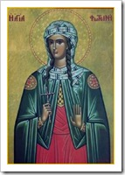
Commemorated on March 20 (also commemorated on February 26 & the “Sunday of the Samaritan Woman”)
St. Photini lived in first century Palestine. She was the Samaritan woman who Christ visited at the well asking her for water. It was she who accepted the “living water” offered her by Christ Himself after repenting from her many sins (John. 4:5-42). She went and told her townspeople that she had met the Christ. For this, she is sometimes recognized as the first to proclaim the Gospel of Christ. She converted her five sisters (Ss. Anatole, Photo, Photis, Paraskeve, and Kyriake) and her two sons (Victor and Joses). They all became tireless evangelists for Christ.
The apostles of Christ baptized her and gave her the name of Photini which means “the enlightened one.” She is remembered by the Church as a Holy Martyr and Equal to the Apostles. After Ss. Peter and Paul were martyred, St. Photini and her family left their homeland of Sychar, in Samaria, to travel to Carthage to proclaim the Gospel of Christ there.
Kontakion (Tone 1)

O Almighty Saviour, Who poured forth water for the Hebrews from a solid rock: You came to the Land of Samaria, and addressed a woman, whom You did attract to faith in You, and she has now attained life in the heavens everlastingly.

Source: http://www.antiochian.org/node/17560

ZACCHÆUS
The story of Zacchæus is told in Luke 19:1-10.
Who was Zacchæus?
____________________________________________________________________________________________________________________________________________________________________________________________________________________________________________________________________________________________________________________________________________________
What does Exodus 22:1 require?
____________________________________________________________________________________________________________________________________________________________________________________________________________________________________________________________________________________________________________________________________________________
How do you read Luke 19:8? Specifically, is it in the present or past tense?
____________________________________________________________________________________________________________________________________________________________________________________________________________________________________________________________________________________________________________________________________________________

Zacchæus vows to change his life. This is his conversion. What are the main elements of Zacchæus vow?
____________________________________________________________________________________________________________________________________________________________________________________________________________________________________________________________________________________________________________________________________________________
The story of Zacchæus begins the Lenten cycle in the Byzantine Church. Zacchæus worked on his faith. How do we work on our Faith, especially during Lent?
____________________________________________________________________________________________________________________________________________________________________________________________________________________________________________________________________________________________________________________________________________________________________________________________________________

ST. PETER
We are all very familiar with the story of St. Peter. He was one of the first Apostles called, and he is the Apostle that is most mentioned in the Gospel. St. Peter is clearly the leader of the Apostles.
When St. Peter is called, what does he admit?
____________________________________________________________________________________________________________________________________________________________________________________________________________________________________________________________________________________________________________________________________________________
Do we admit the same thing?
____________________________________________________________________________________________________________________________________________________________________________________________________________________________________________________________________________________________________________________________________________________

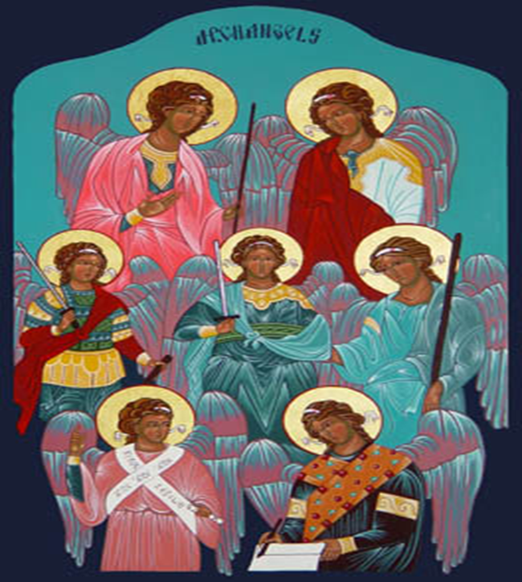
Class 4—Faith and Daily Life
Living the Byzantine Faith

Opening Prayer
In the name of the Father,  and of the Son and of the Holy Spirit. Amen.
Glory to You our God, Glory to You.
Prayer to Holy Spirit
Heavenly King, Comforter, the Spirit of Truth, present in all places and filling all things, Treasury of Blessing and Giver of life: come and dwell within us. Cleanse us of all stain, and save our souls, O Gracious Lord.
Trisagion Prayer
Holy God,  Holy and Mighty, Holy and Immortal, have mercy on us. (3)
Glory to the Father,  and to the Son and to the Holy Spirit, now and ever and forever. Amen.
Most Holy Trinity, have mercy on us. Lord, cleanse us of our sins. Master, forgive our transgressions. Holy One, come to us and heal our infirmities, for Your name’s sake.
Lord, have mercy. (3)
Glory to the Father,  and to the Son and to the Holy Spirit, now and ever and forever, Amen.
Lord’s Prayer
Our Father, Who art in Heaven, hallowed be Thy name. Thy Kingdom come, Thy will be done, on earth as it is in Heaven. Give us this day our daily bread; and forgive us our trespasses, as we forgive those who trespass against us; and lead us not into temptation, but deliver us from evil. For Thine is the Kingdom and the Power and the Glory, Father,  Son and Holy Spirit, now and ever and forever. Amen.

The Didache, one of the oldest Christian documents, calls for each of us to have a rule of prayer. If however, for whatever reason we cannot, The Didache advises saying “Our Father” three times a day.

READINGS FOR CLASS 4
Readings that will be covered in Class:
- James 2: 14-16—Faith and Works
- Romans 4: 1-8—Faith
Supplemental Readings:
- Letter to the Galatians—Works

FAITH AND WORKS
As we discussed previously, our Faith developed from some of the early heresies. In a similar way, the services of both the Eastern and Western Churches developed from the great issues that each of the Churches faced. In the East, the principle discussion was about the nature of the Trinity. In the West, discussion centered around other issues, such as the Real Presence. You can see this reflected in such Roman Catholic liturgical events such as the Benediction of the Sunday of Corpus Christi. The Real Presence was never disputed in the East, so there was no organic development of such celebrations.
One of the great issues in Christianity is the dynamic tension between Faith and Works. This issue was not really discussed in the Eastern Church until the Protestant Reformation in the West. The Jewish Faith, of which we are the heirs, was really a “Faith of Works.” There was very little in the way that an Israelite, or indeed, a modern Jewish adherent had to believe and profess. The Jewish faith depended principally on actions. You had to make pilgrimages at certain times of the year. You had to make certain sacrifices at certain times. You had to take certain actions such as leaving the stubble of the fields for the widows. We have seen Jesus was critical of how far the requirement of works had been extended.
It was only a matter of time until the question of Justification was raised in Christianity.

Read Romans 4:1-8. What does St. Paul say about Faith?
________________________________________________________________________________________________________________________________________________________________________________________________________________________________________________________________________________________________________________________

St. Paul opposed the Jewish doctrine of works. Do you remember what practice St. Paul particularly disapproved of? Why?
________________________________________________________________________________________________________________________________________________________________________________________________________________________________________________________________________________________________________________________

How does St. Paul seem to make the distinction about which Jewish laws to keep, and which to disregard?
________________________________________________________________________________________________________________________________________________________________________________________________________________________________________________________________________________________________________________________

Read James 2:14-16. What does St. James say about Works?
________________________________________________________________________________________________________________________________________________________________________________________________________________________________________________________________________________________________________________________

How do we reconcile these two Epistles?
________________________________________________________________________________________________________________________________________________________________________________________________________________________________________________________________________________________________________________________
It is important to remember that when we read the whole Bible, we must read the entire Bible, to get the entire perspective on a particular subject. Reading only selected passages or books as opposed to others leads to having a “canon within a canon”, forming an entirely new system of beliefs.
Icon of the Holy Family with James
Some traditions of the Eastern and Western Churches differ. The heritage of St. James, the Brother of Jesus is one such example. The Catholic Church calls these complementary, not competing. It is an example of how the Church breathes with both lungs.

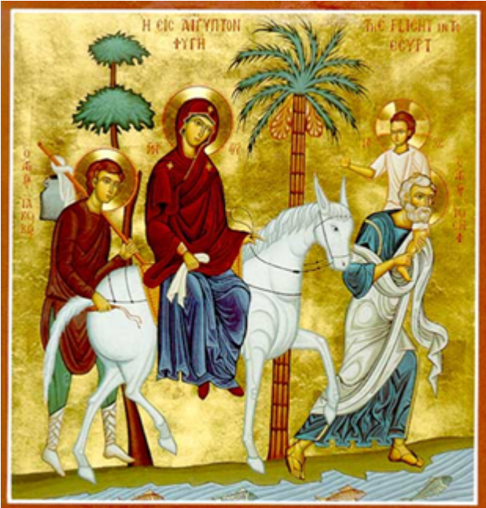

READING THE BIBLE
- There are many different approaches to reading the Bible, some more effective than others. Trying to read it from cover to cover, sequentially. This is admirable, but often is the least effective way to read the Bible. You start with great intentions, but then begin to “run out of steam” when you encounter some of the more difficult readings in the Bible (i.e. Leviticus).

- Reading the Books of the Bible by Season. This is a suggested approach, and very appropriate to the Byzantine Church. Reading four chapters a day can cover the Bible over the course of the year. We read the Books of the Bible during Liturgical Seasons. A simple, suggested list for beginners for the first year would look like this:
The Great Fast
Gospel of Mark
Genesis
Proverbs
Isaiah
First and Second Thessalonians
Holy Week
The Passion Narratives of all the Gospels
Job
Zechariah
Zephaniah

Easter Season
The Gospel of John
Acts of the Apostles
Joel

After Pentecost, During the Apostles Fast
Gospel of Matthew
Letter to the Romans

After the Apostles Fast (June 29)
First Corinthians
Second Corinthians
Ephesians
Colossians
First and Second Samuel
First and Second Maccabees

After the Exaltation of the Cross (September 14)
Gospel of Luke
First Timothy
Second Timothy
Titus
Hebrews

After Philips Fast (November 15)
James
Jude
First Peter
Second Peter
First, Second and Third John
Malachi

After Christmas/Theophany
Hebrews
The remaining books can be spread throughout the second year of reading.
- Using the Bible to pray. If you read one Psalm per day, you will cover the Psalms twice in one year. There are also “canticles” in the Bible as well which are useful for praying. There are seven in total that the Byzantine Church uses for Morning Prayer. The two most commonly prayed are in Luke 1. These are the Canticle of Mary and the Canticle of Saint Zechariah.

SERVICES OF THE EASTERN CHURCH

The Divine Liturgy.

The Divine Liturgy is the centerpiece of our worship. We have three forms of this Liturgy:
- The Liturgy of St. Basil the Great – a longer, theologically sophisticated Liturgy celebrated approximately ten times per year: the Sundays of Lent: the evenings of Easter, the Theophany, and Christmas; and January 1, the feast of St. Basil.
- The Liturgy of St. John Chrysostom – a shorter version of the Liturgy of St. Basil celebrated most Sundays and weekdays.
- The Liturgy of the Presanctified Gifts – a Vespers and Communion service used on weekdays during Lent.

The Liturgy of the Hours.

An extension of the Divine Liturgy. They are celebrated throughout the day as follows:
- Vespers – (Greek: Hesperinos) Sundown, the beginning of the liturgical day.
- Compline (Greek: Apodeipnon, lit. “After-supper”) – After the evening meal prior to bedtime.
- Midnight Office – Usually served only in monasteries.
- Matins (Greek: Orthros) – First service of the morning. Usually starts before sunrise.
- Hours – First, Third, Sixth, and Ninth – Sung either at their appropriate times, or in aggregate at other customary times of convenience. If the latter, The First Hour is sung immediately following Orthros, the Third and Sixth together and the Ninth prior to Vespers.

Other Services

- Moleben – Also called the service of supplication. Derived from Matins
- Panachida and Parastas – Services for the deceased. Derived from Matins.
- Akathist – Hymns of great beauty often used during Compline. The most famous is the Akathist to the Virgin, sung during the Fridays of Lent.
- Paraklesis – A service of supplication to the Theotokos, centered around the Canon of Supplication to the Virgin.
- Canon – a meditative prayer composed of nine odes.

SOME SUGGESTIONS FOR DEEPENING THE FAITH
- Read the Bible. Please see our suggestions for reading the Books of the Bible.
- Develop a Regular Prayer Rule. One suggestion for busy people is:
  - Begin and end the day with prayer. Do it immediately after rising in the morning, and right before you go to bed.
  - Prayer before and after meals.
  - Remember God throughout the day, even for short periods of time.
  - Memorize a short prayer rule that you can use on a regular basis. A couple of suggestions are included in this book.
  - Use the pew book. It has prayers for the beginning and the end of the Divine Liturgy.
- Keep the Fast periods. We have four during the year:
  - The Great Fast (before Easter)
  - The Apostles Fast (After All Saints Sunday until the Feast of Ss. Peter and Paul)
  - The Dormition Fast (August 1 through August 14)
  - Philips Fast (November 15 through the Nativity)
  - The last three do not carry the depth of the Great Fast, but nevertheless we should try to keep them as best we can.
- Keep fasting days throughout the year:
  - Most Fridays of the year.
  - August 29 (Beheading of St. John the Baptist)
  - September 14 (the Exaltation of the Cross)
- Give generously to the poor and to the Church.
- Be Faithful--Attend Church:
  - On Sundays
  - On Holydays
  - Once or twice per week additionally during the Great Fast
  - For special services.
  - Post your Byzantine calendar in a prominent place and check the bulletin for services during the week.
- Read and learn about your Faith
  - Local Bible Classes
  - Read a good book about your Faith. If you read one or two a year, you will be amazed how much you will pick up.
  - Never be afraid to ask questions of the clergy, either in Church, or via email.
- Seek guidance through confession.

SOME PRAYER RULES

A Shorter Prayer Rule

The Jesus Prayer is a venerable prayer of the Church. It is a simple prayer rule that can be easily memorized:

Oh God, be merciful to me a sinner.
Oh God, cleanse me of my sin and have mercy on me.
Oh Lord, you are my creator, have mercy on me.
Oh Lord, forgive me for I have sinned without number.

Virgin Lady, Theotokos, save me.
My Holy Guardian Angel, protect me from all harm.
Holy Saint (name), pray to God for me.

Lord Jesus Christ, Son of the living God, have mercy on me a sinner. (One hundred times).

(The above can often be shortened for your personal taste, or substitute a favorite verse from Scripture).

Monks will sometimes pray the Jesus prayer for a set period of time (such as twenty minutes) or up to six thousand times a day!

A Longer Prayer Rule

Another prayer rule is that given to St. Pachomius by the angel. It too can be memorized with some effort.

It consists of:
1. The Usual Beginning Prayers
2. Psalm 50 (51)
3. The Creed
4. A body of prayer. For instance, one hundred Jesus Prayers or other prayers according to your taste.
5. “It is truly proper…”

ST. PACHOMIUS
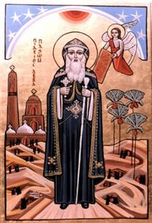
Troparion
As a pastor of the Chief Shepherd/ you guided flocks of monks into the heavenly sheepfold / yourself illumined, you instructed others concerning the Habit and Rule./ And now you rejoice with them in the heavenly mansions.

Kontakion
O God-bearing Pachomius, after living the life of Angels in your body/ you were granted their glory./ Now you are standing with them before God’s throne/ and praying that we all may be forgiven.

St. Pachomius was born about 292 in the Upeer Thebaid in Egypt and was inducted into the Emperor’s army as a twenty-year-old. The great kindness of Christians at Thebes toward the soldiers became embedded in his mind and led to his conversion after his discharge. After being baptized, he became a disciple of an anchorite, Palemon, and took the habit. The two of them led a life of extreme austerity and total dedication to God; they combined manual labor with unceasing prayer both day and night. Later, Pachomius felt called to build a monastery on the banks of the Nile at Tabennisi; so about 318 Palemon helped him build a cell there and even remained with him for a while. In a short time some one hundred monks joined him and Pachomius organized them on principles of community living. So prevalent did the desire to emulate the life of Pachomius and his monks become, that the holy man was obliged to establish ten other monasteries for men and two nunneries for women. Before his death in 346, there were seven thousand monks in his houses, and his Order lasted in the East until the 11th century. St. Pachomius was the first monk to organize hermits into groups and write down a Rule for them. Both St. Basil and St. Benedict drew from his Rule in setting forth their own more famous ones.

Notes—Class 1

Notes-Class 2

Notes—Class 3

Notes—Class 4

Course Evaluation

Rate each item from 1 to 5 where 1 is strongly disagree and 5 is strongly agree.

ORGANIZATION
___My interest was quickly engaged.

___The introduction gave me a clear idea of the topic.

___The introduction gave me a clear idea of the direction the presentation would take.

___I could easily follow the main points of the presentation.

___The order in which the points were presented made sense to me.

___The conclusion did a good job of summarizing the content of the presentation.

CONTENT
___The points made were well supported.

___I was convinced by the speaker’s presentation.

___The presentation made me interested in learning more about this subject.

OVERALL COMMENTS
What did you like best about the presentation?

What areas might you suggest for improvement?

Do you have any questions you wish to pursue further? If so, please leave your email address with your question.

