Course Evaluation (formerly SOP) Report
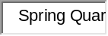

Course Code: 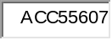

Instructor (Status): 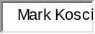

Region, Campus: 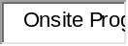
PART A: EVALUATION OF INSTRUCTOR | Average Score (a) | Percentage of Respondents (%)
PART A: EVALUATION OF INSTRUCTOR | Average Score (a) | Strongly Agree | Agree |  | Disagree (b)
Q1A. Clearly informed students of course objectives | 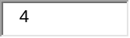 | 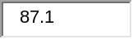 | 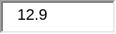 |  | 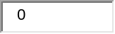
Q1B. Clearly explained theoretical concepts in course |  | 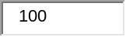
Q1C. Class presentations explained course contents effectively
Q1D. Answered questions effectively
Q1E. Instructional technology used effectively | 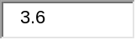 | 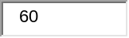 | 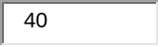
Q1F. Real-world projects & examples were used effectively
Q1G. Sufficient reading & assignments to master material
Q1H. Grading of students' work done in a timely manner
Q1I. Instructor was available outside the classroom
Q1J. Instructor was prepared & organized for class
Q1K. Instructor was enthusiastic about teaching course material
Q1L. Instructor consistently treated students with respect | 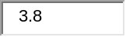 | 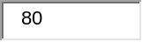 | 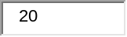
SUMMARY RESULTS
Q1M. Overall, the instructor was an effective teacher
Grading & Availability: Q1H & Q1I combined
Instructor Attributes: Q1D, Q1J, Q1K & Q1L combined | 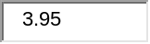 | 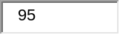 | 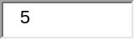
Instructional Effectiveness: Q1A to Q1C & Q1E to Q1G combined | 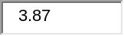 | 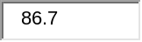 | 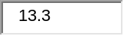
a. Average score of item on a scale from one (“strongly disagree”) to four (“strongly agree’).
b. Combines “strongly disagree” and “disagree” ratings.

PART B: EVALUATION OF COURSE DESIGN | Average Score (a) | Percentage of Respondents (%)
PART B: EVALUATION OF COURSE DESIGN | Average Score (a) | Strongly Agree | Agree |  | Disagree (b)
Q2A. Course syllabus clearly stated learning objectives
Q2B. Textbook helped to understand course material
Q2C. Course was intellectually challenging
Q2D. Course improved knowledge of subject
Q2E. Felt academically prepared to take course
Q2F. Prepared to take more advanced courses | 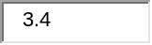
SUMMARY RESULTS
Course-Relatedness Score (Q2A to Q2D combined) | 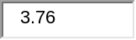 | 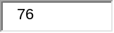 | 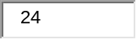
Preparedness Score (Q2E & Q2F combined) | 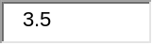 | 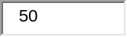
a. Average score of item on a scale from one (“strongly disagree”) to four (“strongly agree’).
b. Combines “strongly disagree” and “disagree” ratings.

OVERALL PERFORMANCE | Instructor | Performance |  | All
OVERALL PERFORMANCE | This Course Section  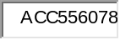 | All Course Sections Taught |  |  | University  Faculty
Overall Part A Statistics
Average Score (1 to 4 scale) |  |  |  |  | 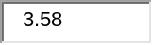
Strongly Agreeing (%) |  |  |  |  | 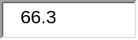
Agreeing (%) |  |  |  |  | 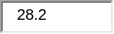
Disagreeing (%) |  |  |  |  | 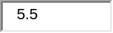
NetPromoter™ Statistics
Mean Rating (zero to ten scale) | 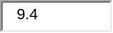 |  |  |  | 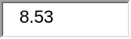
Promoters (Percent rating instructor as 9 or 10) |  |  |  |  | 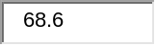
Passives (Percent rating instructor as 7 or 8) |  |  |  |  | 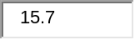
Detractors (Percent rating instructor from 0 to 6)
NetPromoter™ Score |  |  |  |  | 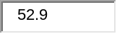
Course Evaluation (formerly SOP) Survey Information
Number of Course Sections | 1 | 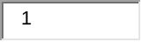 |  |  | 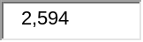
Number of Student Respondents |  |  |  |  | 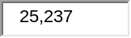
Student Response Rate | 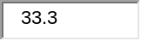 |  |  |  | 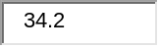
Student Comments,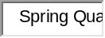

Course Code:

Instructor (Status):

Region, Campus:

Number of comments regarding the instructor (Q4): 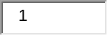



Number of additional comments regarding this course (Q5): 